**Model Development Phase Template**

|  |  |
| --- | --- |
| Date | 12 November 2024 |
| Team ID | team-739849 |
| Project Title | PixelProse - Crafting Visual Stories with Intelligent Image Captioning |
| Maximum Marks | 10 Marks |

**Initial Model Training Code, Model Validation and Evaluation Report**

The initial model training code will be showcased in the future through a screenshot. The model validation and evaluation report will include a summary and training and validation performance metrics for multiple models, presented through respective screenshots.

**Initial Model Training Code (5 marks):**

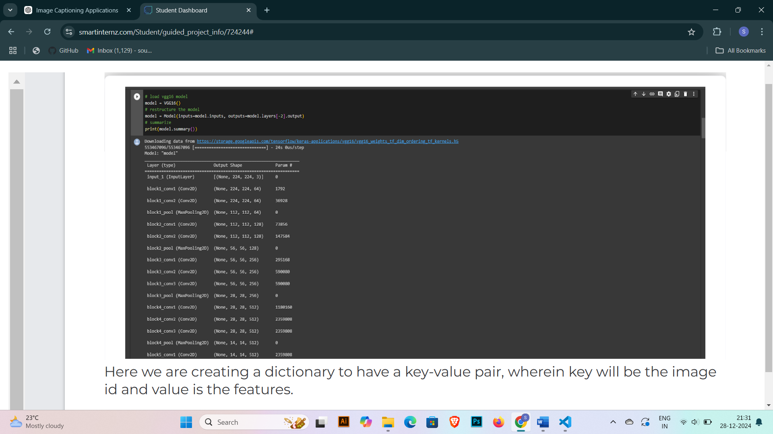

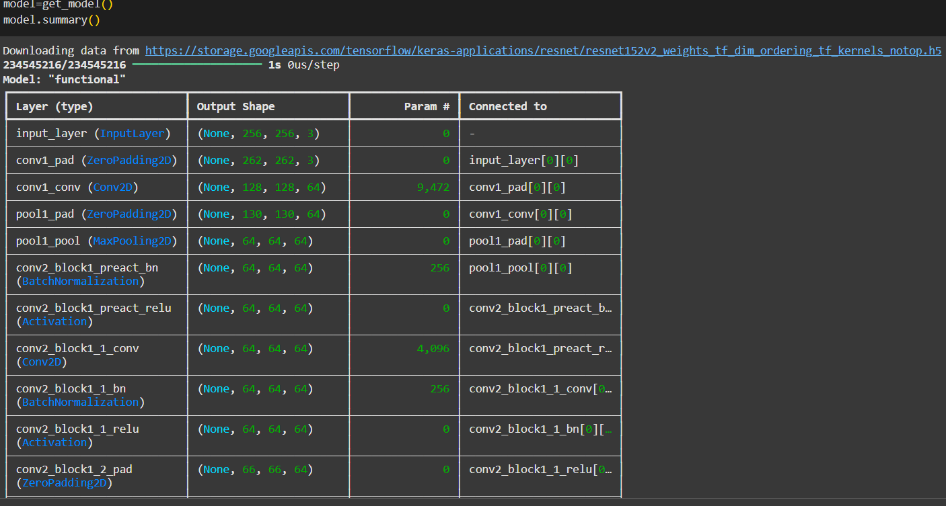

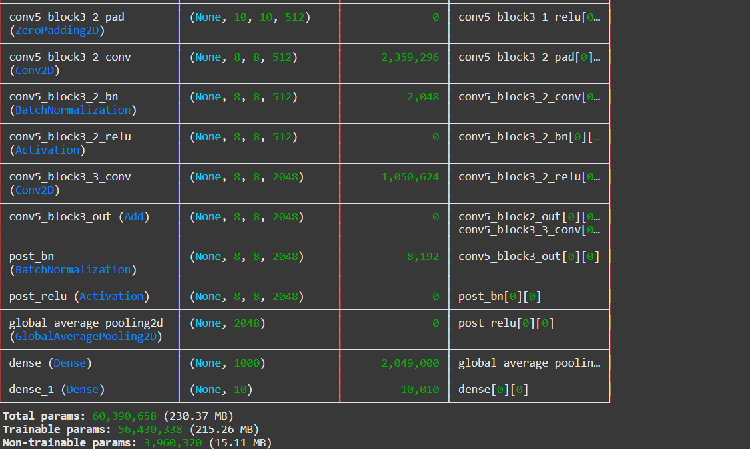

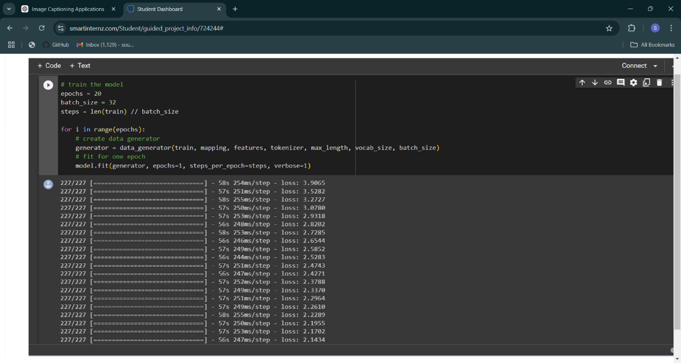

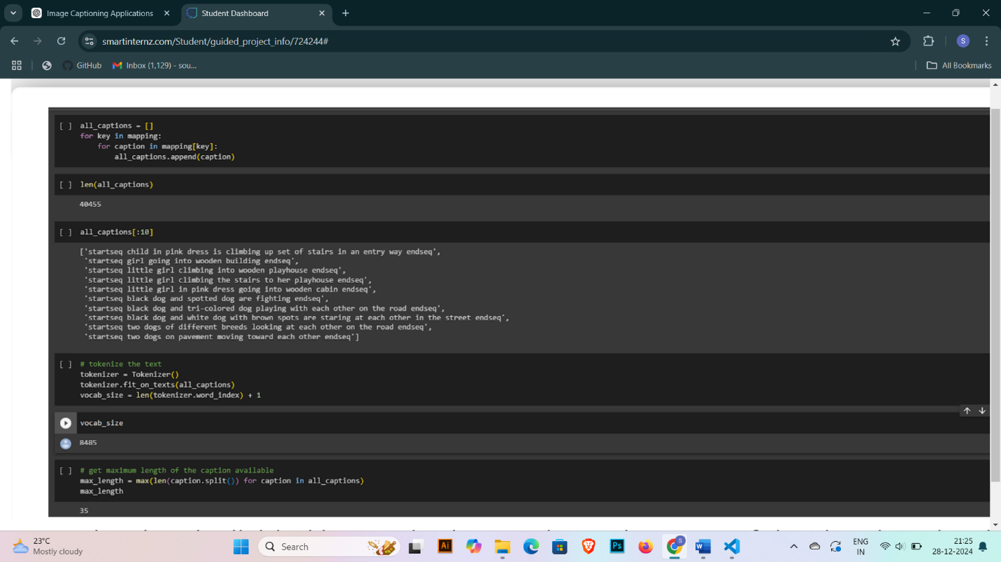

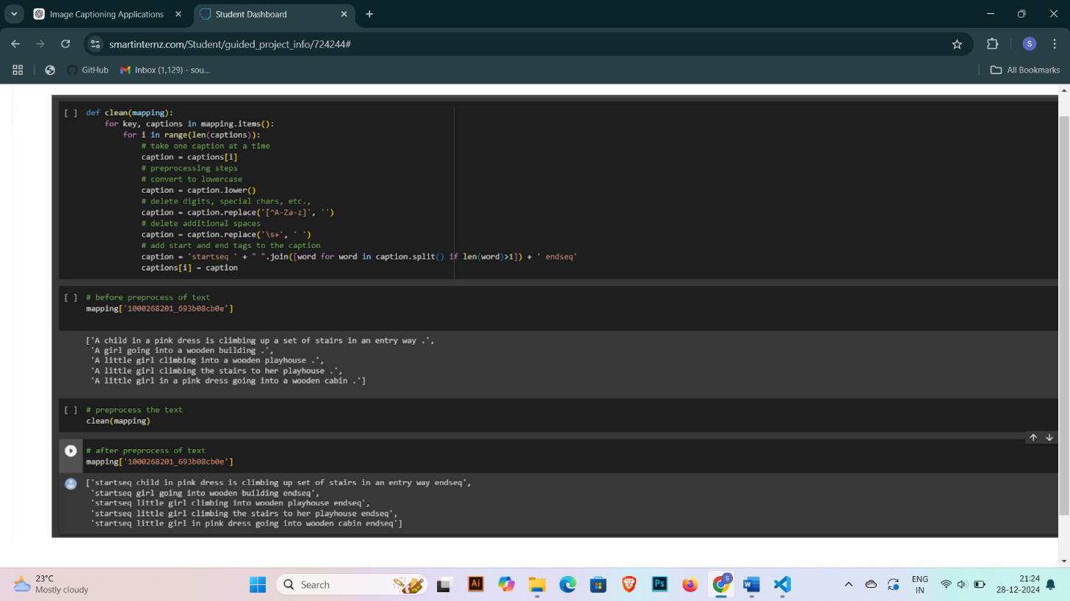

**Model Validation and Evaluation Report (5 marks):**

|  |  |  |
| --- | --- | --- |
| **Model** | **Summary** | **Training and Validation Performance Metrics** |
| InceptionV3 | Inception v3 is a highly efficient and accurate convolutional neural network (CNN) architecture, widely used for image classification and feature extraction tasks. Developed as part of the Google Inception series, it improves computational efficiency while maintaining high performance.  **Factorized Convolutions:** Breaks down large convolutions into smaller, more efficient ones, reducing computation time and improving performance.  **Auxiliary Classifiers:** Incorporates auxiliary outputs during training to improve gradient flow and prevent overfitting.  **Batch Normalization:** Normalizes input data across layers to accelerate convergence and stabilize training. |  |